**Insights**

1. **The High-Income/Occupation Segments to Maximize Revenue**

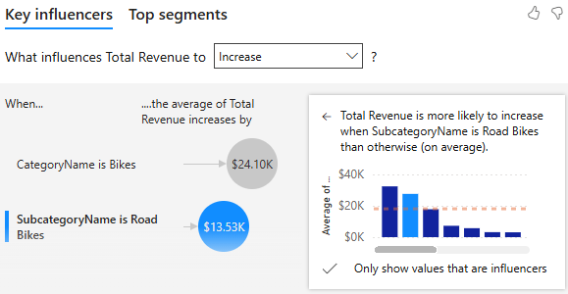

This links Road Bikes from Bikes Categorygenerate the most revenue for the company and to target them for cross-selling of products

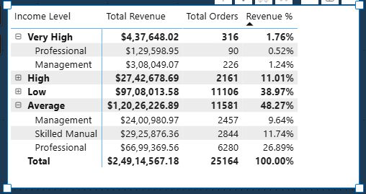

The Customers with Occupation as Professionals with Average Income Level generate the most revenue. This tells you the demographic to target with personalized offers or who to prioritize in acquisition / Marketing campaigns.

1. **Marketing Strategy & Campaign Response**

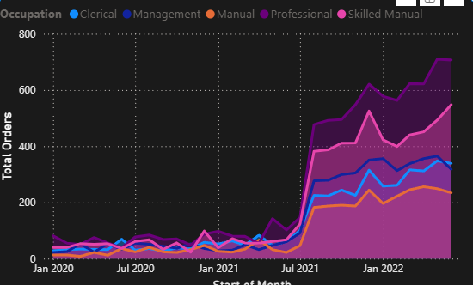

The **Total Orders** after the period of July 2021 spiked immediately, providing direct evidence of any campaigns which could have been led by the marketing team.

**Revenue by Product Category for Key Demographics**

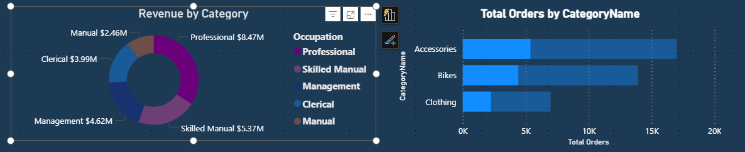

The bar chart filters to show which product categories professionals spend the most on. Since Accessories is highest, your personalized outreach to Professionals should exclusively promote Accessories. This will optimize campaign relevance.

**Recommendations**

**Marketing Strategy**

The **'Average' Income** segment (comprising 46% of customers) accounts for **49% of total revenue**. Their purchases are concentrated in high-margin products like 'Road Bikes’.

Reallocation of the marketing budget to personalized email campaigns targeting the ‘Average’ income segment with exclusive offers on new high-margin products, aiming for a 15% increase in AOV (Average Order Value)

**High Margin Product Opportunity**

While **Bikes** drive the highest total revenue, they yield a **Gross Margin of only 41.74%**. Conversely, the **Accessories** category, despite having a smaller revenue contribution, maintains an extremely high **67.88% Gross Margin**.

**Action:** This high profitability suggests that cross-selling and bundling accessories with every major purchase should be a core strategy to immediately boost overall company profit

Integrate accessories more aggressively into the sales process. Train sales staff and optimize the e-commerce checkout flow to always cross-sell at least two high-margin accessory items to every customer purchasing a Bike.